Projektas „Europos kreditų perkėlimo ir kaupimo sistemos (ECTS) nacionalinės koncepcijos parengimas: kreditų harmonizavimas ir mokymosi pasiekimais grindžiamų studijų programų metodikos kūrimas bei diegimas“ VP1-2.2-ŠMM-08-V-01-001
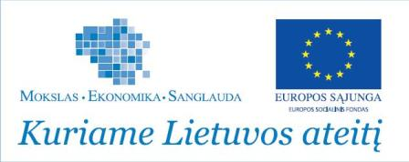 |  | 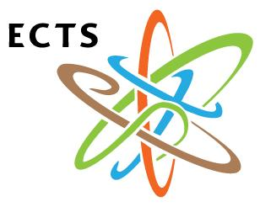

DESCRIPTION OF THE MODULE

TITLE OF THE MODULE | Code

Teacher(s) | Department
Coordinating:

Others:

Study cycle | Level of the module | Type of the module

Form of delivery | Duration | Langage(s)

Prerequisites
Prerequisites: | Co-requisites (if necessary):

Credits of the module | Total student workload | Contact hours | Individual work hours

Aim of the module (course unit): competences foreseeen by the study programme
...

Learning outcomes of module (course unit) | Teaching/learning methods | Assessment methods
- ...

- ...

- ...

- ...

- ...

Themes | Contact work hours |  |  |  |  |  |  | Time and tasks for individual work
Themes | Lectures | Consultations | Seminars | Practiacl work | Laboratory work | Placements | Total contact work | Individual work | Tasks
1.

2.

3.

4.

5.

6.

7.

8.

9.

10.

Iš viso

Assessment strategy | Weight in % | Deadlines | Assessment criteria

Author | Year of issue | Title | No of periodical or volume | Place of printing. Printing house or intrenet link

Compulsory literature

Additional literature

